Friday 18th September 2026

Attendance Matters
Autumn 1 Attendance

 | Wk1 | Wk2 | Wk3 | Wk4 | Wk5 | Wk 6 | Wk 7 | Wk8
Nursery |  |  | 85.7
Reception |  |  | 97.2
Year 1 | 91.1 | 94.1 | 93.7
Year 2 | 97.1 | 99.0 | 86.6
Year 3 | 95.1 | 95.8 | 96.1
Year 4 | 95.0 | 95.3 | 90.3
Year 5 | 97.8 | 98.0 | 96.3
Year 6 | 95.6 | 96.3 | 93.3
Whole school | 95.3 | 96.5 | 93.1
Well done Year 2 you have the best attendance this week.
Whole school Attendance is running at 94.7%


Young Voices
Young Voices letters were sent out to KS2 last week. Please make sure that you are signed up on Parent Pay and the Music Room by Friday 25th September 2026 to secure your place! We are nearly 60% full in just a week so please make sure you sign up soon to secure your place!

More information regarding an optional after school club to help learn the songs will be sent out after this date for those children who are attending. The after school club will begin after half term week.

Online Safety for Parents
Each week, we are aiming to provide you with information to help keep your children safe when online. This links to the Online Safety mind maps the children complete with their class teachers at the start of each half term.

IOS 27 Parental features

Apple's latest iOS 27 update released on Tuesday and includes several new tools to help parents keep children safe online and develop healthy screen habits.

Key updates include:
- Ask to Browse: Children must request permission before accessing new websites.
- Improved Screen Time: Parents can more easily monitor and manage device use.
- Time Allowances: Set daily limits for categories such as games, entertainment and social media.
- Contact Approvals: Parents can approve new contacts before children communicate with them.
- Enhanced Safety Features: Added protection against graphic and violent content, alongside existing safeguards.

Parents can access these features through Settings > Family > Screen Time on updated Apple devices. These tools are designed to work best alongside regular conversations about online safety and responsible technology use.

Reminder
Edgmond Hall Residential Trip
Wednesday 26th – 28th May 2027
Years 2, 3, 4, 5 and 6

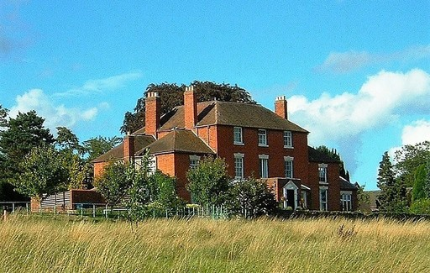

Dear Parent/ Guardian
We are really excited to be organising a trip to Edgmond Hall, and we are making it available to all children in Years 2, 3,4, 5 and 6!
This is a 2-night residential visit which involves lots of fun and many new learning experiences. From past visits we have found that children are able to enhance their learning through outdoor activities that wouldn’t be experienced during a normal school day. School and Edgmond Hall staff will arrange a detailed programme.

The children will be accompanied by at least 4 members of school staff and the course is well supported by appropriately qualified and experienced Centre staff.

How much will it cost?
£148 standard fee for the cost of accommodation, meals, educational materials and activities
£17 for the Coach
£1 insurance
The total cost of this trip would be £167.00.

When would the trip need to be paid for?
The trip would need to be paid for by Friday 21st May 2027
This can be paid in a variety of ways including instalments or in full, all options are via parent pay.

What to do if you would like to reserve a place for your child?

Places are limited and therefore we are operating on a first come first served basis. If you would like a place for your child, please complete the consent on parent pay to secure your place no later than Wednesday 30th September.
When we have final numbers, we will be holding a meeting in for all parents of children going on the trip, in the meantime if you have questions or queries regarding this trip, please do not hesitate to ask.
Over the years we have taken children, who have a wide variety of different needs, including nighttime issues. If would like to discuss any delicate issues again, please do not hesitate to speak to myself.
For more information, please follow this link Edgmond Hall Centre for Outdoor Learning

Year 5 and Year 6 Parents
Please see below dates and times for open days at local secondary schools.
School | Date(s) | Type | Time
Bristnall Hall Academy | Saturday 19th September 2026  Weeks commencing Monday 21st and Monday 28th September 2026 | Open Morning  Open Fortnight | 10am – 1pm.  During school day (booking required – details on website)
George Salter Academy | Tuesday 22nd September 2026 | Open Evening | TBC – check website
Gospel Oak School | Thursday 17th September 2026 | Open Evening | 6pm - 8pm.
Holly Lodge Secondary School | Wednesday 23rd September 2026  Saturday 26th September 2026  Friday 18th September and Tuesday 29th September | Open Evening  Open Morning  Open Morning (school day) | 5pm -7pm  9.30am -11.30am  9.30am - 10.45am
Oldbury Academy | Monday 21st September 2026  22nd, 23rd, 24th & 25th September 2026 | Open Evening  Open Mornings | 5:00pm – 7:00pm (booking required via school website)  9.30am (booking required via school website)
Ormiston Forge Academy | Thursday 24th September 2026  Saturday 26th September 2026  Week commencing Monday 28th September 2026 | Open Evening  Open Morning  Tours | Evening (see website for details)  Morning (See website for details)  By appointment only
Ormiston Sandwell Community Academy | Tuesday 22nd September 2026  Wednesday 23rd Thursday 24th and Friday 25th September 2026 | Open Evening  Open Mornings | TBC – Check website  TBC – Check website
Perryfields Academy | Wednesday 9th September 2026  Thursday 17th September 2026  Saturday 19th September 2026  Friday 25th September 2026 | Open Morning  Open Evening  Open Morning  Open Morning | 9am – 10am. Bookings here.  5pm – 7pm. Bookings here.  10am – 11am  9am – 10am. Bookings here.
Phoenix Collegiate | Thursday 17th September 2026 | Open Evening | 4pm - 7.30pm
Q3 Academy – Great Barr | Thursday 1st October 2026 | Open Evening | 4:30 – 7pm.
Q3 Academy – Langley | Thursday 24 September 2026  Week Commencing 28 September 2026 | Open Evening  Open Mornings | 5pm – 9pm. No booking required.  9am – 11am. Bookings via school website.
Q3 Academy – Tipton | Saturday 26 September 2026 | Open Evenings | 9am – 11.30am. Bookings here.
Sandwell Academy | 16th September 2026  5th October 2026 | Open Evening  Open Evening | TBC – Check website
Shireland Biomedical University Technical College | Thursday 17th September 2026  Saturday 19th September 2026 | Open Evening  Open Day | 4pm – 7pm  10am – 1pm
Shireland Collegiate Birmingham Symphony Orchestra Academy | 16th September 2026  19th September 2026 | Open Evening  Open Morning | 5pm - 7:30pm  9am - 11am
Shireland Collegiate Academy | Tuesday 15th September 2026  Wednesday 16th - Friday 18th September 2026 | Open Evening  Open Day Tours | TBC – Check website.
St Michael’s Church of England High School | Wednesday 16th September 2026  Thursday 17th September 2026 | Open Evening  Open Day | TBC – Check website
Stuart Bathurst Catholic High School | Thursday 24th September 2026 | Open Evening | 6pm - 8pm
West Bromwich Collegiate Academy | Thursday 10th September 2026 | Open Evening | 4.30pm - 8pm
Windsor Olympus Academy | Wednesday 24th September  Thursday 25th September and Friday 26th September | Open Evening  Open Morning | 5pm  9am
Wodensborough Ormiston Academy | Wednesday 16th September  Wednesday 21st October | Open Evening  Open Evening | 4:30pm - 7:30pm  3:30pm - 5pm
Wood Green Academy | Wednesday 23rd September 2026 | Open Evening | 5:30pm – 7.30pm

Year 7 applications
Please follow this link to make your secondary school application. Closing date for applications is 31st October 2026
Apply for a school place | Sandwell Council


Before School Drop Off club – here if you need us
Sessions need to be booked with Mrs Sirett in the office. It runs from 8am to 8.45am. Cost is £3 per session, sessions taken will be added to ParentPay on each Friday and are expected to be paid the same day. Credit can be added to the Rogmans Breakfast Payment item and will only be taken if a session is attended.

Reminder we are a Nut and Banana free school


We have children in school with a severe allergy to nuts and bananas, we cannot have any nuts, nut products, bananas or banana products in school. Please do not send them in packed lunches or as a playtime snack.

Do you shop at Tesco???
If you shop at Tesco Quinton superstore or Tesco Express Bristnall/ Hagley Road please vote for Annie Lennard using a token, you receive each time you shop from the 4^{th of} August

Has anything changed?
If any of your details has changed such address, phone number, email address etc please email changes to the following email address or please come to the main office to update your details.
admin.office@annielennard.sandwell.sch.uk

Parent Governor Vacancy
We have a vacancy for a parent governor on the board. If you are at all interested, please see the letter at the end of this newsletter that has all the information you need. Nominations are to be handed into school by Friday 25th September 2026

Dates for your Diary – 2026 – 2027
More dates will be added as we go throguh the year, this is what we know so far

Month | Date | Event
September | Tuesday 1st | Teacher Training Day – school closed to pupils
 | Wednesday 2nd | School opens for pupils in year 1 to year 6
 | 15th | SEND parent/carer drop in 2:50pm
 | 30th | Harvest assembly with Rev Jenny
October | Wednesday 21st | Year 3 trip to Kinver rock houses – stone age workshop
 | 8th | Year 2 visit to St Hildas
 | 26th – 30th | Half Term Holiday – school closed
November | Monday 2nd | Teacher Training Day – school closed to pupils
 | Tuesday 3rd – 5th | Come and look at our work - parents invited to look at children's books ahead of consultation days 3.15 – 3.30
 | Wednesday 4th | Reception and Year 1 trip to theatre to see The Gruffalo
 | Tuesday 10th | Parent Consultation Day for Reception, Year 2, Year 4 & Year 6
 | Wednesday 11th | Parent Consultation Day for Nursery, Year 1, Year 3 & Year 5
 | Friday 20th | Children in Need
 | Thursday 26th | Year 1 visit to St Hildas
December | 1st | Rev Jenny to work with year 3
 | 1st | Nativity assembly with Rev Jenny
 | 14th | KS1 Christmas Production – 1.30pm school hall.
 | 15th | EYFS Christmas Production – 9.15 school hall
December | 21st – 1st | Christmas Holidays
January | Monday 4th | Return to School
 | Thursday 7th | Year 1, 2, 3 and 4 trip to Chester Zoo
 | Friday 8th | Year 3, 4, 5 and Year 6 choir @ young voices
February | 4th | Rev Jenny Assembly
 | 8th – 11th | Come and look at our work - parents invited to look at children's books ahead of consultation days. 3.15 – 3.30
February | 15th – 19th | Half Term Holiday
 | Tuesday 23rd | Parent Consultation Day for Reception, Year 2, Year 4 & Year 6
 | Wednesday 24th | Parent Consultation Day for Nursery, Year 1, Year 3 & Year 5
March | Thursday 4th | World Book Day
 | 2nd | Year 3 to visit St Hildas
 | 11th | Year 4 to visit St Hildas
 | 18th | Rev Jenny assembly
 | 18th | Rev Jenny working with year 6
 | Friday 19th | Red Nose Day
March/April | Friday 26th March – Friday 9th April | Easter Holidays
April | Monday 12th | Return to School
 | 27th | Reception to visit St Hildas
May | Monday 3rd | Bank Holiday Monday
 | 6th | Year 5 to visit St Hildas
 | 10th – 13th | Year 6 SATS – all year 6 must be in school all week
 | 13th | Rev Jenny assembly
 | 26th – 28th | Year 2, 3, 4 5, and 6 residential trip to Edgmond Hall
 | 31st – 4th | Half Term Holiday
June | Monday 7th | Return to School
 | 7th – 11th | Year 4 Multiplication test administered this week
 | 14th - 18th | Year 1 phonic screening test to be administered this week
 | 29th | Year 6 to visit St Hildas
July | Friday 9th | Reports out to parents
 | Friday 16th | Provisional date for year 6 production
 | Monday 19th | Provisional date for year 6 Prom, 6pm – 8pm @ venue to be confirmed – tickets £15.00 per pupil
 | Wednesday 21st | Year 6 leavers assembly

Apply for your Reception Place – applications open Monday 15th September, please see letter below from Sandwell LA.
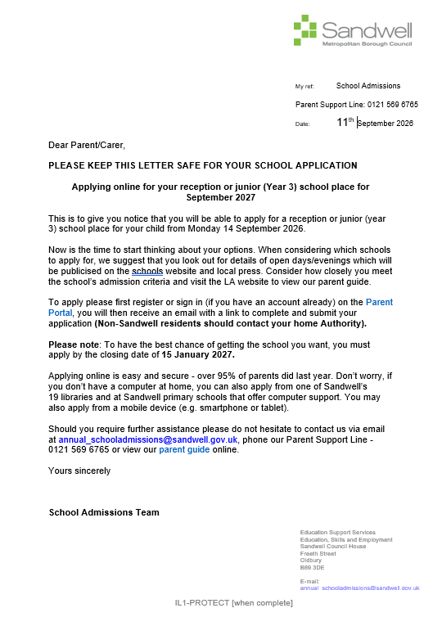
Dear Parent/Carer

Election of Parent Governors

I am writing to invite you to stand for election as a parent governor or nominate another parent to do so. In our school we have provision for 2 parent governor(s) and there is currently 1 vacancy

The governing board, with the headteacher, has overall responsibility for the running of the school. Governing boards have three core strategic functions:

- Ensuring clarity of vision, ethos and strategic direction;
- Holding the headteacher to account for the educational performance of the school and its pupils; and
- Overseeing the financial performance of the school and making sure its money is well spent.

The role of governor can be demanding but very rewarding. Parent governors serve a 4 year term of office and under usual circumstances, can expect to spend between 10 and 20 days a year on governing duties. These include:

- attending meetings of the governing board, usually outside of school hours and contributing to governing board business;
- reading reports and papers and keeping up to date on the progress the school is making; and
- visiting the school from time to time during the school day.

You will be expected to sign a governors’ Code of Conduct, and to have:

- a strong commitment to the role and improving outcomes for children;
- the inquisitiveness to question and analyse;
- the willingness to learn;
- good inter-personal skills;
- appropriate levels of literacy in English (unless a governing board is prepared to make special arrangements); and
- sufficient numeracy skills to understand basic data.

No special qualifications are needed. However a DBS check is a statutory requirement and must be applied for within 21 days of election/appointment. The most important thing is to have a keen interest in the school and be prepared to play an active part in the governing boards work. Training is available for all governors and this governing board has an expectation that those new to being a governor attend induction training.

Parents/carers who have paid employment in the school for 500 or more hours per academic year or who are elected members of the Local Authority are not eligible to stand in these elections. Nominations must be from parents or carers with children at the school on the day those nominations close.

If you would like to stand for election, please complete the enclosed nomination form and return it to the school no later than Friday 18th September 2026. You may also include a short personal statement to support your nomination, which should be no longer than 250 words. Self-nominations will be accepted, but if you are nominating another parent please seek their prior consent. If there are more nominations than vacancies the election will be by secret ballot. If that is necessary, voting papers will be sent to all parents together with details of the ballot procedure.

We must stress that new statutory guidance advises that the governing board publishes online for each governor certain information including their full name, relevant business interests, whether a governor serves on another governing board and relationships with staff in the school. There is a statutory requirement for all governors to have a DBS check and you would be expected to abide by and sign a code of conduct.

May I take this opportunity to thank you in advance for your support in this matter.

Yours faithfully,
Natalie Crozier
Head Teacher

Nomination Form
Election of parent governors

Please enter IN BLOCK LETTERS the name and address of the person being nominated for election:

Name: _______________________________________________________________

Address: _____________________________________________________________
Being the parent/guardian of (name of pupil): _______________________________
Signature of person nominated: __________________________________________

Signature of proposer (if different to nominee): ______________________________

Name and address in BLOCK letters of proposer (if different to nominee):
________________________________________________________________

Personal Statement (maximum 250 words) Please add this on a separate page if needed.

I wish to submit my nomination for the election of parent governor (subject to DBS check).
I confirm a) that I am willing to stand as a candidate for election as a parent governor and b) that I am not disqualified from holding office for any of the reasons set out in the School Governance Regulations.
I understand that neither the headteacher or the Director of Education bear responsibility for the validity of any statement made above.
Signature
(Date)
Completed nomination forms must be returned to the school by Friday 18th September 2026

